Week2:
JUnit Basic Testing Exercises
Exercise 1: Setting Up JUnit
We need to set up a basic Java project using Maven in Visual Studio Code and integrate JUnit for unit testing. The goal is to write and successfully run a sample test case.
Creation of maven project:
archetype: maven-archetype-quickstart
Group ID: com.example
Artifact ID: demo
Added JUnit dependency:
<dependency>
<groupId>junit</groupId>
<artifactId>junit</artifactId>
<version>4.13.2</version>
<scope>test</scope>
</dependency>
App.test.java
Code:
package com.example;

import static org.junit.Assert.assertEquals;
import org.junit.Test;
public class AppTest
{
/**
* Rigorous Test :-)
*/
@Test
public void testAddition() {
assertEquals(4, 2 + 2);
}
}
Running the Test:
Output:

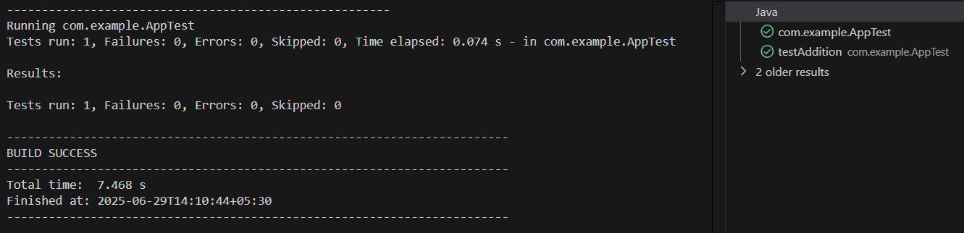

Exercise 3: Assertions in JUnit
Scenario: You need to use different assertions in JUnit to validate your test results.
AssertionsTest.java
Code:
package com.example;

import static org.junit.Assert.assertEquals;
import static org.junit.Assert.assertFalse;
import static org.junit.Assert.assertNotNull;
import static org.junit.Assert.assertNull;
import static org.junit.Assert.assertTrue;
import org.junit.Test;

public class AssertionsTest {
@Test
public void testAssertions() {
assertEquals(5, 2 + 3);
assertTrue(5 > 3);
assertFalse(5 < 3);
assertNull(null);
assertNotNull(new Object());}
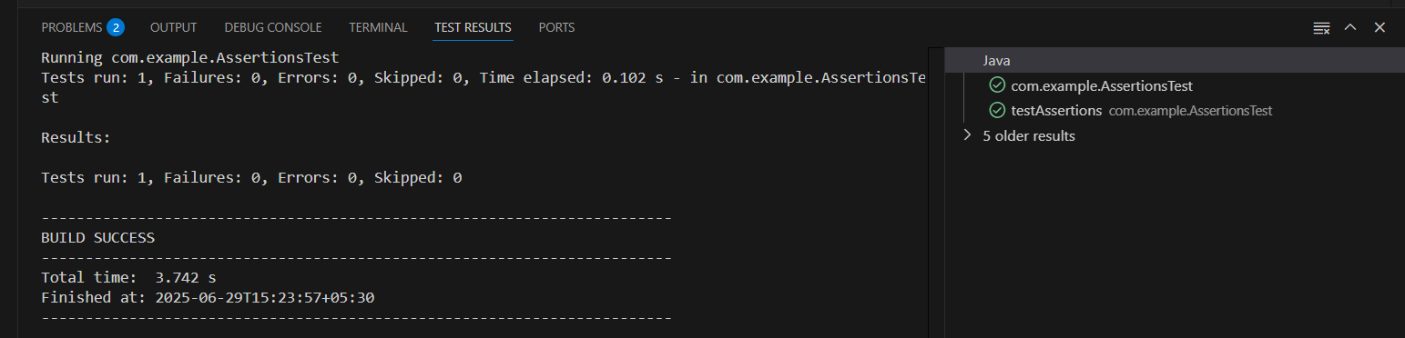
}
Exercise 4:
Arrange-Act-Assert (AAA) Pattern, Test Fixtures, Setup and Teardown Methods in JUnit.
I have used CalculatorTest program to test for it.
CalculatorTest.java
Code:
package com.example;
import org.junit.Before;
import org.junit.After;
import org.junit.Test;
import static org.junit.Assert.*;

public class CalculatorTest {

private Calculator calculator;

// Setup method: runs before each test
@Before
public void setUp() {
calculator = new Calculator(); // Arrange
System.out.println("Setup complete");
}

// Teardown method: runs after each test
@After
public void tearDown() {
calculator = null;
System.out.println("Teardown complete");
}

@Test
public void testAddition() {
// Act
int result = calculator.add(2, 3);

// Assert
assertEquals(5, result);
}

@Test
public void testSubtraction() {
int result = calculator.subtract(10, 4);
assertEquals(6, result);
}
}

Calculator.java:
package com.example;
public class Calculator {
public int add(int a, int b) {
return a + b;
}
public int subtract(int a, int b) {
return a - b;
}
}
Output:
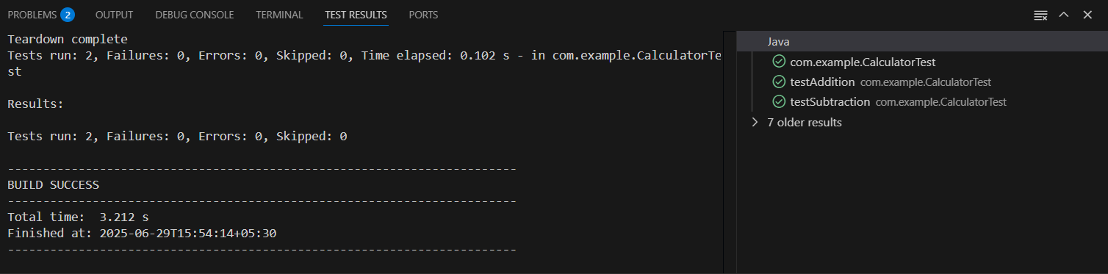

Mockito Exercises
Exercise 1:
Mocking and Stubbing
Scenario:
You need to test a service that depends on an external API. Use Mockito to mock the external API and stub its methods.
Code:
MyService.java
package com.example;

public class MyService {
private ExternalApi api;

public MyService(ExternalApi api) {
this.api = api;
}

public String fetchData() {
return api.getData();
}
}
MyServiceTest.java:
package com.example;
import static org.junit.jupiter.api.Assertions.assertEquals;
import org.junit.jupiter.api.Test;
import static org.mockito.Mockito.mock;
import static org.mockito.Mockito.when;

public class MyServiceTest {

@Test
public void testExternalApi() {
ExternalApi mockApi = mock(ExternalApi.class);
when(mockApi.getData()).thenReturn("Mock Data");

MyService service = new MyService(mockApi);
String result = service.fetchData();

assertEquals("Mock Data", result);
}
}

Added a Mockito dependency in pom.xml:
<dependency>
<groupId>org.mockito</groupId>
<artifactId>mockito-core</artifactId>
<version>4.11.0</version>
<scope>test</scope>
</dependency>

Output:
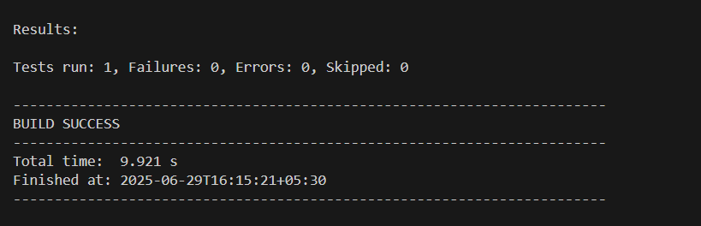
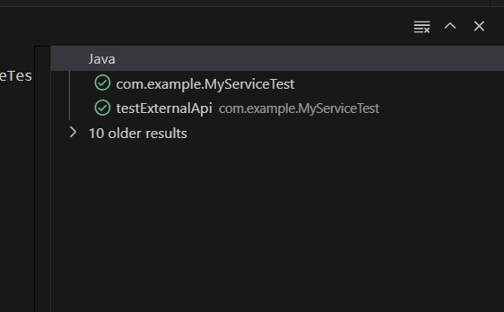

Exercise 2:
Verifying Interactions
Scenario:
You need to ensure that a method is called with specific arguments.
We need to Ensure that your code calls mockApi.getData() when service.fetchData() is executed.
Code:
ExternalApi.java:
( to define the interface)
package com.example;
public interface ExternalApi {
String getData();
}

MyService.java:
(the class using the external API)
package com.example;

public class MyService {
private ExternalApi api;

public MyService(ExternalApi api) {
this.api = api;
}

public String fetchData() {
return api.getData();
}
}
MyServiceTest.java
(verifying the interaction)
package com.example;

import static org.mockito.Mockito.*;
import org.junit.jupiter.api.Test;

public class MyServiceTest {

@Test
public void testVerifyInteraction() {
// Step 1: Create mock object
ExternalApi mockApi = mock(ExternalApi.class);

// Step 2: Use mock in service
MyService service = new MyService(mockApi);
service.fetchData();

// Step 3: Verify method was called
verify(mockApi).getData();
}
}
Output:
